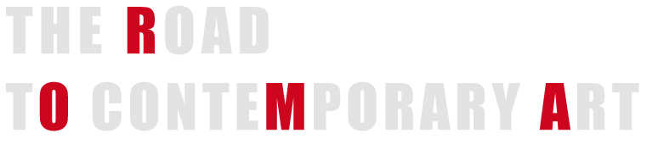

An exhibition, the virtuous circle of art
It is certainly a pleonasm, but Rome is Rome: the town everybody knows, everybody wants to visit and to which everybody wants to come back: the history, the climate, the Mediterranean centrality and easiness of connection, a 26 million passenger airport and an over a hundred and fifty million traveler train station, the main seat of all the national and international media.
For some time, all this has added up to attention paid to the media by the local councils, attention which has paid back in terms of news and articles which rank Rome amongst the most remembered and best described cities not only for its being a state capital, a political city crowded with traditional tourism, but with particular focus on the art events.
We obviously do not refer to classic arts, such as the historical monuments, the Forum, the Coliseum and the like), but to an awakening of interest for contemporaneity in its different forms: from the opening of the Auditorium to other significant architectural projects, from the “Notte bianca” (Sleepless Night) to other musical, theatre and fashion events.
In particular, as regards contemporary art , the establishment – within the Ministry for the Cultural Heritage and Activities – of a Direction exclusively dedicated to contemporary architecture and arts, the decision of implementing MAXXI, a new national museum for the arts of the 21st century, the presence of MACRO and its projects, of the new museum spaces inside and outside the structure, the Mattatoio (“Slaughterhouse), the exhibitions of contemporary international artist, are all signals which indicate the wish of filling this institutional gap on contemporaneity, which has affected the Italian culture (with few exceptions) in the last decades.
To this new institutional ferment, Rome is offering an almost immediate response at private level through the opening of numerous new galleries (some of them as an emanation of large and well known international ones), new spaces for exhibitions, gatherings, events.
If appropriately devised and managed, an exhibition is the greatest synthesis of such virtuous circle which sees the convergence of the artist, the gallery director, the critic, the public and private market into only one pathway characterized by the quality and significance of the different characters involved in the shared objective to the advantage of both the individuals and the collectivity.
Furthermore, for the very reason that it involves all the great protagonists of the sector in unity of time, place and action this is also – as mentioned above – a tremendous tool for communication and promotion for the those who are involved in contemporary art within the territory, as well as for the whole city.
The worldwide scenario of contemporary art fairs is particularly rich and tough. To mention but the most important successful events we may recall: Art Basel and Miami Basel, Art Forum in Berlin, Fiac in Paris, Arco in Madrid, the Armory Show in New York, Frieze in London, and Artissima in Turin, besides Art Cologne, Art Brussels, and Artefiera in Bologna.
To be known and emerge in such competitive state of affairs, the project of a new exhibition is to have substantial, specific features which will distinguish it from the other ones, and create a unique, exclusive event to call the attention of both the visitors and potential exhibitors.

