Cultbytes

Pattern, Decoration, and the New Avant-Garde at Art Basel Miami
Anna Mikaela Ekstrand
December 3, 2021
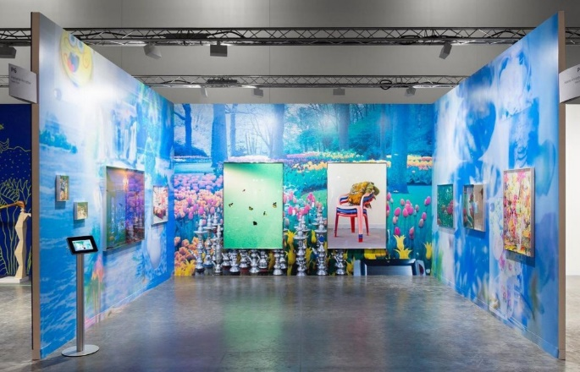
Farah Al Qasami at Helena Anrather, Art Basel Miami Beach 2021.
Last week I caught the last day of “With Pleasure: Pattern and Decoration in American Art 1972-1978” at Hessel Museum of Art at Bard College that presented work from the Pattern and Decoration – or P&D. A movement characterized by artists incorporating decorative arts, crafts, architecture, and ornament in their work. Many techniques discredited because of their “femininity” – quilting, lace, embroidery – or disregarded because they were not taught in art schools, like Islamic patterns and architecture. It is also the only modern movement to be dominated by female artists. Elements from this groundbreaking and overlooked movement has now made it into the mainstream, or rather, more pluralistic and less hierarchical expressions are finally a la mode and can all be seen at this year’s Miami Art Week.
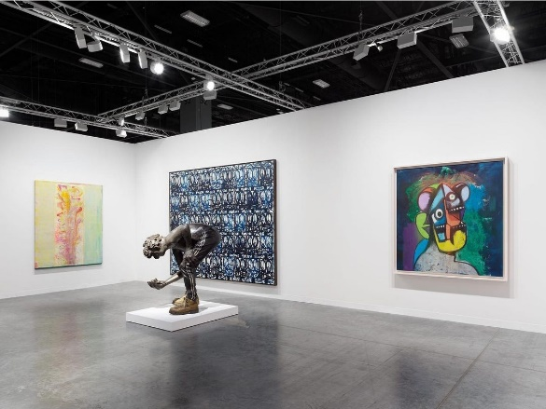
Far right: Frank Bowling at Hauser and Wirth, Art Basel Miami Beach, 2021.
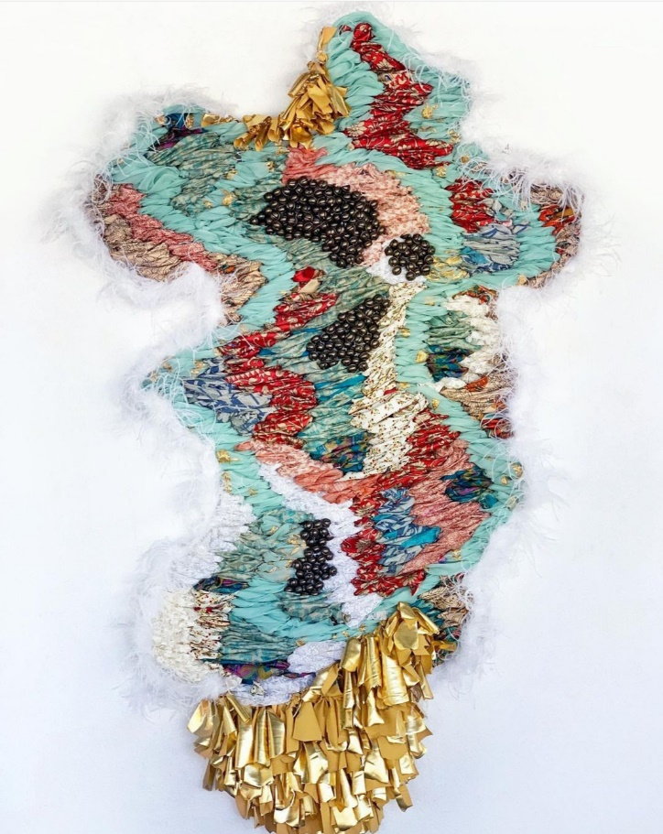
To Art Basel Miami Beach, Xavier Hufkens have brought a lovely Lynda Benglis wall sculpture, Tree Fern, 2015, incorporating sparkles. She is also in the P&D show. Pace has another, sleeker, aluminum sculpture, Figure 1, 2012. Representation overall, culling artists from diverse backgrounds, is a hot topic in the art world. Kavi Gupta showed A mended heart, a lightened soul and A murmer of a prayer, both 2021 by Guyanese artist Suchitra Mattai who has used every day wearable objects tied to her cultural heritage – cut, woven, and tied vintage saris with mounts of ghungroo bells – to create new landscapes, or maps. Guyana’s population reflects its colonial legacy comprised of people of Indian, African, Chinese, Portuguese, English, and Scottish descent who have retained much of their culture. Comparable only in heritage, Hauser and Wirth brought a spectacular mesmerizing Frank Bowling in hues of pinks, green, red, and yellows. Bowling, who was born in British Guiana has spent most of his adult in between the United Kingdom and America, has focused his over sixty-decade long career on expanding the possibilities of paint. Sharing these images with my Guyanese family sparked jovial conversations and pride for the country they left long ago. Art is all about finding points of connections: connecting to the work itself, the artist, the work’s provenance, how it operates in dialog with the world beyond it and the more time an art work exists in the world the richer its story becomes.
Suchitra Mattai at Kavi Gupta, Art Basel Miami Beach 2021.

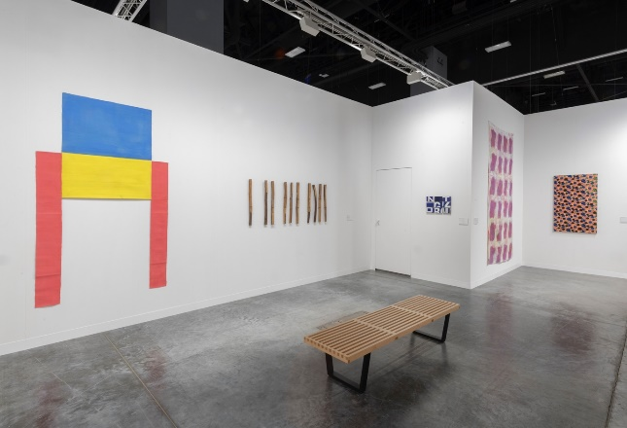
Support/Surface artists at Ceysson & Bénétière, Art Basel Miami Beach 2021.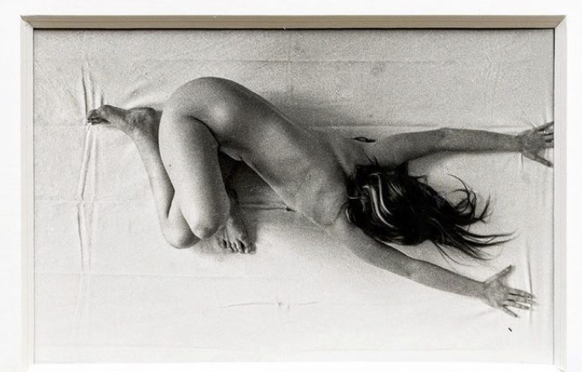ORLAN at Ceysson & Bénétière, Art Basel Miami Beach 2021.
The P&D exhibition at the Hessel Museum highlighted the importance of collectors as the museum’s co-founder Marieluise Hessel was an advocate of the movement. As I navigate through the fairs in Miami, I always wonder what works will make their ways into museum collections and exhibitions and through which pathways – acquired directly by museums, through gifts, or loans. Ceysson & Bénétière, the gatekeepers of the Support/Surface movement, brought museum worthy works by the French group of artists. Breakouts are, Loie Cane cut outs canvases and a large netted work by Claude Viallat, tied ropes delicately hanging from the wall in a grid, and a smaller version of a large scale work the gallery featured in Meridians two years ago. Like P&D, artists of the Support/Surface movement created work in response to American Abstract Expressionists and as a revolt to the institutionalized art world most visibly through the display of the work – leaning and hanging on walls, buildings, and in nature, and their choice of material netting, rope, and fabric replacing canvas to deconstruct modalities and philosophies of painting.
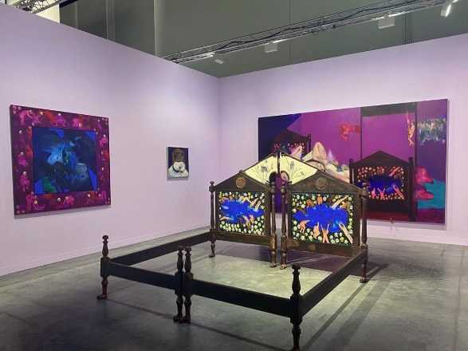
As part of Kabinett, Ceysson & Bénétière are showing a collection of exquisite photographs by a young, 17–18-year-old, ORLAN taken in 1964. The artist has had a long career working with her body, ranging from selling kisses outside of Grand Palais to reinventing her body through plastic surgery – body modification – as performance documented on film. Her work conflates identity and image, often serving as performances of new identities. These early images tell of what is to come through the unusual ways she contorts her body, and are an important piece in understanding the development of her artistic oeuvre.
Ambera Wellman at Company Gallery, Art Basel Miami Beach 2021. All images courtesy of the galleries.
Multiple expressions of maximalism serve to reflect and criticize our time. The solo presentation of Emirati artist Farah Al Qasami presents photographs and a video work in an immersive environment in purples, blues, and pinks – millennial colors, and chandeliers, roses, clouds, and layers of consumer goods reflecting excess achieved through consumption and digital retouching. In the video the artist is a social media influencer trapped within a wellness app. A generation trying to photograph themselves to happiness by curating their lives to look good on social media. Swedish artist Cajsa von Zeipel’s collection of sculptures on view at the Rubell Museum fall within the same category although her work leans further into queer culture. These works oscillate between empowerment and submission to capital and social pressure. Company Gallery, who represent Cajsa von Zeipel, have brought work by Ambera Wellmann paintings and a bedframe, with shapes and techniques referencing folk art and modern European painters.
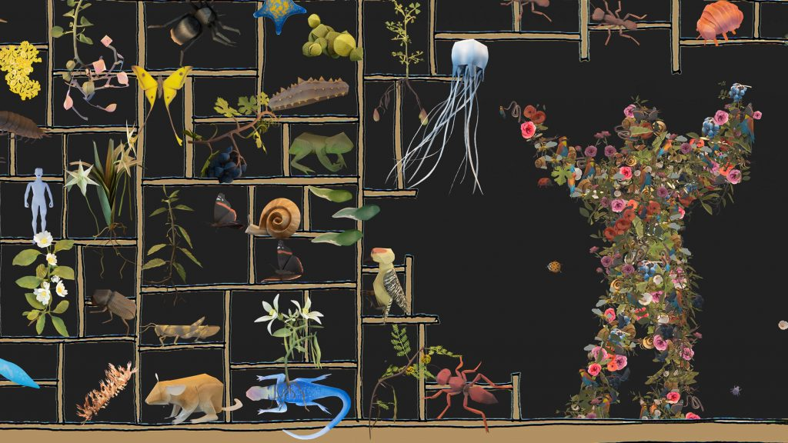
mischer’traxler present the interactive installation “Embodied nature” at Design Miami 2021.
Across the street from ABMB, at Design Miami, Austrian design studio mischer’traxler present the interactive installation Embodied nature centering around biodiversity. To break the hierarchy of species, visitors are invited to move in front of a wall where their silhouette is projected through hundreds of plant types, small mammals, and insects. The installation also presents magnified models of species in shelves, the overall setting resembling a larger than life-size cabinet of curiosities. The design team researched nine ecosystems from around the globe to stage this biodiverse interconnected meeting. Sponsored by champagne producer Maison Perrier-Jouët the piece is a sleek and discrete reminder that we humans need to rethink our relationship to nature.
At NADA, KDR305 is showing works by Miami-based Nicaraguan painter and ceramicist Joel Gaitan. His hand-built terracotta clay pots are expressive – akin to Joakim Ojanen who is showing some works at The Hole, but distinctly referencing and celebrating Mesoamerican art history and Nicaraguan culture. 56 Henry has an ambitious booth which she rotates daily, when I visited three paintings by Jo Messer were on view. Scenes taking placed within every day interiors, Messer melds abstraction and figuration, erotic and mundane. There are some traces of her former teacher Cecily Brown in her broad brush strokes, but Messer’s work is uniquely her own. Liza Lacroix’s two large abstract oil paintings with humorous titles in Magenta Plains group presentation squarely stand out among the fairs many figurative paintings. I will watch anything and everything. He is forever, 2021 plays with both depth and surface through its unusual color pairing and erratic mark making that smears, floats, and whirls. At SCOPE, a new guard of artists are showing, one of them is collage artist Kelly Dabbah, a trained fashion designer that works across the intersections of art, fashion, and design. Through her popular Instagram account she has become a desirable candidate for brand partnerships including work with Moleskin, Anna Sui, and neon company Yellow Pop. Dabbah is showing a series of mirrors and a vintage chair printed with her digital collage that investigates body image, cannabis culture, and consumerism. Within P&D, Miriam Schapiro’s femmage, feminist collage, carved out a space for female artists and crafts traditionally gendered female, Dabbah continues this trajectory creating work to empower its viewers.
Artists create new worlds, often forcing us to confront the world we live in. Through the sheer number of works it presents, Miami Art Week, opens a window into what is yet to come.

